Trillions for the Bankers, Debts for the People
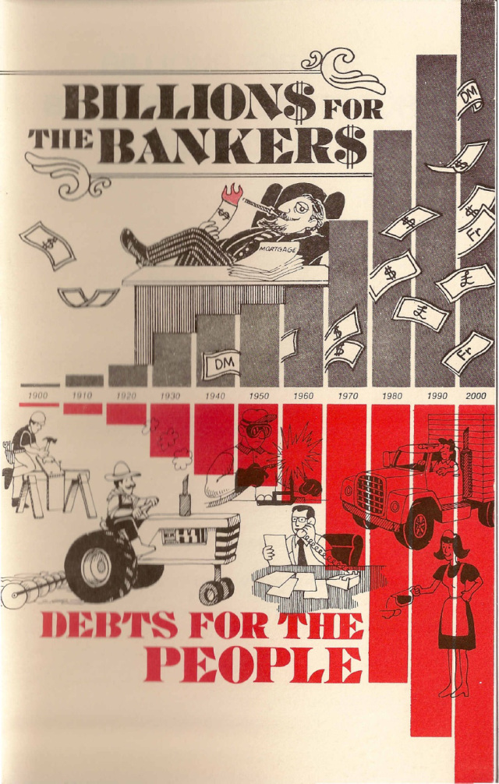


The Real Story of the Money-Control Over America
by
Sheldon Emry
This study on money is not copyrighted. It may be reproduced in whole or in part for the purpose of helping the American people.
Three Types Of Conquest
History reveals nations can be conquered by the use of one or more of three methods. The most common is conquest by war. In time, though, this method usually falls, because the captives hate the captors and rise up and drive them out if they can. Much force is needed to maintain control, making it expensive for the conquering nation.
A second method is by religion, where men are convinced they must give their captors part of their earnings as “obedience to God.” Such a captivity is vulnerable to philosophical exposure or by overthrow by armed force, since religion by its nature lacks military force to regain control, once its captives become “disillusioned.”
The third method can be called economic conquest. It takes place when nations are placed under “tribute” without the use of visible force or coercion, so that the victims do not realize they have been conquered. “Tribute” is collected from them in the form of “legal” debts and taxes, and they believe they are paying it for their own good, for the good of others, or to protect all from some enemy. Their captors become their “benefactors” and “protectors.” Although this is the slowest to impose, it is often quite long-lasting, as the captives do not see any military force arrayed against them, their religion is left more or less intact, they have freedom to speak and to travel, and they participate in “elections” for their rulers. Without realizing it, they are conquered, and the instruments of their own society are used to transfer their wealth to their captors and make the conquest complete. In 1900 the average American worker paid few taxes and had little debt.
“If the American people ever allow private banks to control the issue of their money, first by inflation and then by deflation, the banks and corporations that will grow up around them (around the banks), will deprive the people of their property until their children will wake up homeless on the continent their fathers conquered”. - Thomas Jefferson
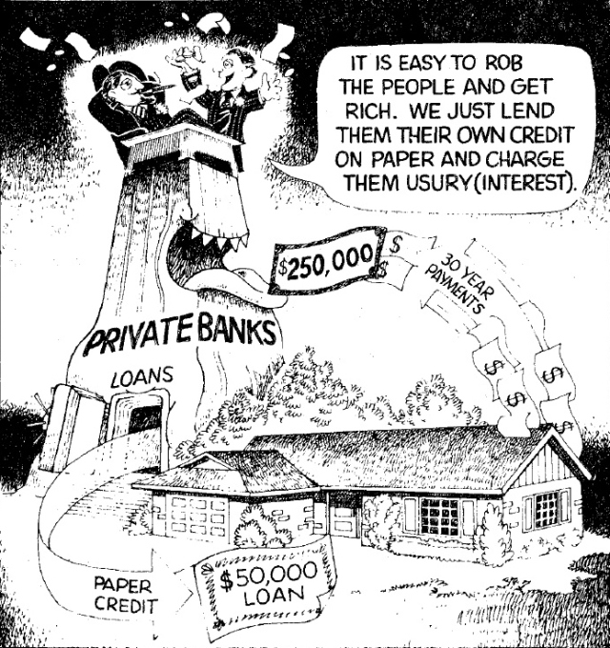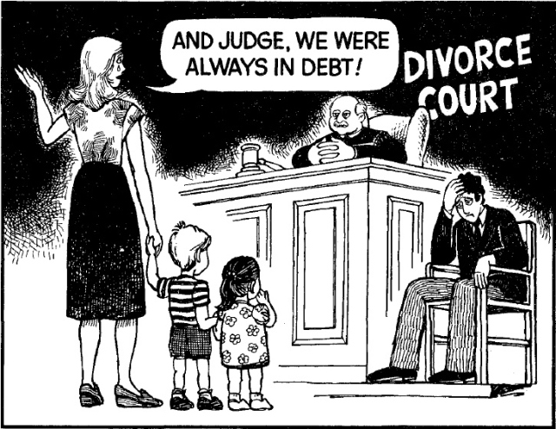

Americans, living in what is called the richest nation on earth, seem always to be short of money. Wives are working in unprecedented numbers, husbands hope for overtime hours to earn more, or take part-time jobs evenings and weekends, children look for odd jobs for spending money, the family debt climbs higher, and psychologists say one of the biggest causes of family quarrels and breakups is “arguments over money.” Much of this trouble can be traced to our present “debt-money” system.
Too few Americans realize why Christian Statesmen wrote into Article I of the U.S. Constitution:
Congress shall have the Power to Coin Money and Regulate the Value Thereof.
They did this, as we will show, in prayerful hope it would prevent “love of money” from destroying the Republic they had founded. We shall see how subversion of Article I has brought on us the “evil” of which God’s Word had warned.

Money is Man’s Only “Creation”
Economists use the term “create” when speaking of the process by which money comes into existence. Now, creation means making something that did not exist before. Lumbermen make boards from trees, workers build houses from lumber, and factories manufacture automobiles from metal, glass and other materials. But in all these they did not “create,” they only changed existing materials into a more usable and, therefore, more valuable form. This is not so with money. Here, and here alone, man actually “creates” something out of nothing. A piece of paper of little value is printed so that it is worth a piece of lumber. With different figures it can buy the automobile or even the house. Its value has been “created” in the true meaning of the word.
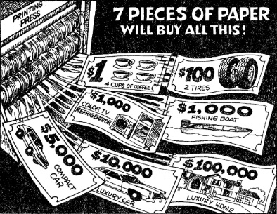

Money “Creating” Profitable
As is seen by the above, money is very cheap to make, and whoever does the “creating” of money in a nation can make a tremendous profit! Builders work hard to make a profit of 5% above their cost to build a house.
Auto makers sell their cars for 1% to 2% above the cost of manufacture and it is considered good business. But money “manufacturers” have no limit on their profits, since a few cents will print a $1 bill or a $10,000 bill.
That profit is part of our story, but first let us consider another unique characteristic of the thing — money, the love of which is the “root of all evil.”

Adequate Money Supply Needed
An adequate supply of money is indispensable to civilized society. We could forego many other things, but without money industry would grind to a halt, farms would become only self-sustaining units, surplus food would disappear, jobs requiring the work of more than one man or one family would remain undone, shipping and large movements of goods would cease, hungry people would plunder and kill to remain alive, and all government except family or tribe would cease to function.
An overstatement, you say? Not at all. Money is the blood of civilized society, the means of all commercial trade except simple barter. It is the measure and the instrument by which one product is sold and another purchased. Remove money or even reduce the supply below that which is necessary to carry on current levels of trade, and the results are catastrophic. For an example, we need only look at America’s Depression of the early 1930’s.

The Bankers Depression of the 1930’s
In 1930 America did not lack industrial capacity, fertile farmland, skilled and willing workers or industrious farm families. It had an extensive and highly efficient transportation system in railroads, road networks, and inland and ocean waterways. Communications between regions and localities were the best in the world, utilizing telephone, teletype, radio, and a well-operated government mail system. No war had ravaged the cities or the countryside, no pestilence weakened the population, nor had famine stalked the land. The United States of America in 1930 lacked only one thing: an adequate supply of money to carry on trade and commerce.
In the early 1930’s, Bankers, the only source of new money and credit, deliberately refused loans to industries, stores and farms. Payments on existing loans were required however, and money rapidly disappeared from circulation. Goods were available to be purchased, jobs waiting to be done, but the lack of money brought the nation to a standstill. By this simple ploy America was put in a “depression” and the greedy Bankers took possession of hundreds of thousands of farms, homes, and business properties. The people were told, “times are hard,” and “money is short.” Not understanding the system, they were cruelly robbed of their earnings, their savings, and their property.
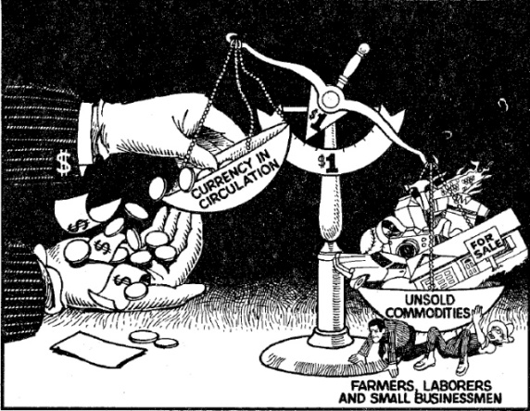

Money for Peace? No! Money for War? Yes!
World War II ended the “depression.” The same Bankers who in the early 30’s had no loans for peacetime houses, food and clothing, suddenly had unlimited billions to lend for Army barracks, K-rations and uniforms! A nation that in 1934 couldn’t produce food for sale, suddenly could produce bombs to send free to Germany and Japan! (More on this riddle later.)
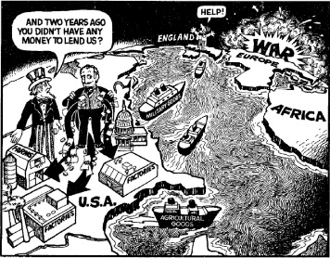
With the sudden increase in money, people were hired, farms sold their produce, factories went to two shifts, mines re-opened, and “The Great Depression” was over! Some politicians were blamed for it and others took credit for ending it. The truth is the lack of money (caused by the Bankers) brought on the depression, and adequate money ended it. The people were never told that simple truth and in this article we will endeavor to show how these same Bankers who control our money and credit have used their control to plunder America and place us in bondage.

Power to Coin and Regulate Money
When we can see the disastrous’ results of an artificially created shortage of money, we can better understand why our Founding Fathers, who understood both money and God’s Laws, insisted on placing the power to “create” money and the power to control it ONLY in the hands of the Federal Congress. They believed that ALL citizens should share in the profits of its “creation” and therefore the national government must be the ONLY creator of money. They further believed that ALL citizens, of whatever State or Territory, or station in life would benefit by an adequate and stable currency and therefore, the national government must also be, by law, the ONLY controller of the value of money.
Since the Federal Congress was the only legislative body subject to all the citizens at the ballot box, it was, to their minds, the only safe depository of so much profit and so much power. They wrote it out in the simple, but all-inclusive: “Congress shall have the Power to Coin Money and Regulate the Value Thereof.”

How the People Lost Control
to the Federal Reserve
Instead of the Constitutional method of creating our money and putting it into circulation, we now have an entirely unconstitutional system. This has resulted in almost disastrous conditions, as we shall see.
Since our money was handled both legally and illegally before 1913, we shall consider only the years following 1913, since from that year on, ALL of our money has been created and issued by an illegal method that will eventually destroy the United States if it is not changed. Prior to 1913, America was a prosperous, powerful, and growing nation, at peace with its neighbors and the envy of the world. But — in December of 1913, Congress, with many members away for the Christmas holidays, passed what has since been known as the FEDERAL RESERVE ACT. (For the full story of how this infamous legislation was forced through our Congress, read Conquest or Consent, by W. B. Uennard). Omitting the burdensome details, it simply authorized the establishment of a Federal Reserve Corporation, with a Board of Directors (The Federal Reserve Board) to run it, and the United States was divided into 12 Federal Reserve “Districts.”
This simple, but terrible, law completely removed from Congress the right to “create” money or to have any control over its “creation,” and gave that function to the Federal Reserve Corporation. This was done with appropriate fanfare and propaganda that this would “remove money from politics” (they didn’t say “and therefore from the people’s control”) and prevent “Boom and Bust” from hurting our citizens. The people were not told then, and most still do not know today, that the Federal Reserve Corporation is a private corporation controlled by bankers and therefore is operated for the financial gain of the bankers over the people rather than for the good of the people. The word “Federal” was used only to deceive the people.

More Disastrous Than Pearl Harbor
Since that “day of infamy,” more disastrous to us than Pearl Harbor, the small group of “privileged” people who lend us “our” money have accrued to themselves all of the profits of printing our money — and more! Since 1913 they have “created” tens of billions of dollars in money and credit, which, as their own personal property, they then lend to our government and our people at interest. “The rich get richer and the poor get poorer” had become the secret policy of our National Government. An example of the process of “creation” and its conversion to people’s “debt” will aid our understanding.

They Print It —
We Borrow It and Pay Them Interest
We shall start with the need for money. The Federal Government, having spent more than it has taken from its citizens in taxes, needs, for the sake of illustration, $1,000,000,000. Since it does not have the money, and Congress has given away its authority to “create” it, the Government must go the the “creators” for the $1 billion. But, the Federal Reserve, a private corporation, doesn’t just give its money away! The Bankers are willing to deliver $1,000,000,000 in money or credit to the Federal Government in exchange for the Government’s agreement to pay it back — with interest! So Congress authorizes the Treasury Department to print $1,000,000,000 in U.S. Bonds, which are then delivered to the Federal Reserve Bankers.
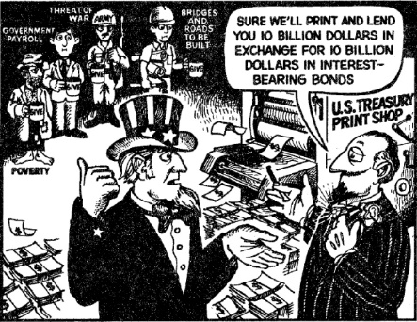
The Federal Reserve then pays the cost of printing the $1,000,000,000 (about $1,000) and makes the exchange. The Government then uses the money to pay its obligations. What are the results of this fantastic transaction? Well, $1 billion in Government bills are paid all right, but the Government has now indebted the people to the Bankers for $1 billion on which the people must pay interest! Tens of thousands of such transactions have taken place since 1913 so that by the 1980’s, the U.S. Government is indebted to the Bankers for over $1,000,000,000,000 (trillion) on which the people pay over $100 billion a year in interest alone with no hope of ever paying off the principal. [In 1995, the total Federal Debt has grown to over $5 trillion, with an annual interest payment of $203 billion, 14% of the federal budget. -Ed] Supposedly our children and following generations will pay forever and forever!

And There’s More
You say, “This is terrible!” Yes, it is, but we have shown only part of the sordid story. Under this unholy system, those United States Bonds have now become “assets” of the Banks in the Reserve System which they then use as “reserves” to “create” more “credit” to lend. Current “reserve” requirements allow them to use that $1 billion in bonds to “create” as much as $15 billion in new “credit” to lend to States, Municipalities, to individuals and businesses. Added to the original $1 billion, they could have $16 billion of “created credit” out in loans paying them interest with their only cost being $1,000 for printing the origina1 $1 billion! Since the U.S. Congress has not issued Constitutional money since 1863 (over 100 years), in order for the people to have money to carry on trade and commerce they are forced to borrow the “created credit” of the Monopoly Bankers and pay them usury-interest!

And There’s Still More
In addition to the vast wealth drawn to them through this almost unlimited usury, the Bankers who control the money at the top are able to approve or disapprove large loans to large and successful corporations to the extent that refusal of a loan will bring about a reduction in the price that that Corporation’s stock sells for on the market. After depressing the price, the Bankers’ agents buy large blocks of the stock, after which the sometimes multi-million dollar loan is approved, the stock rises, and is then sold for a profit. In this manner billions of dollars are made with which to buy more stock. This practice is so refined today that the Federal Reserve Board need only announce to the newspapers an increase or decrease in their “rediscount rate” to send stocks up and down as they wish. Using this method since 1913, the Bankers and their agents have purchased secret or open control of almost every large corporation in America. Using that control, they then force the corporations to borrow huge sums from their banks so that corporation earnings are siphoned off in the form of interest to the banks. This leaves little as actual “profits” which can be paid as dividends and explains why stock prices are so depressed, while the banks reap billions in interest from corporate loans. In effect, the bankers get almost all of the profits, while individual stock holders are left holding the bag.
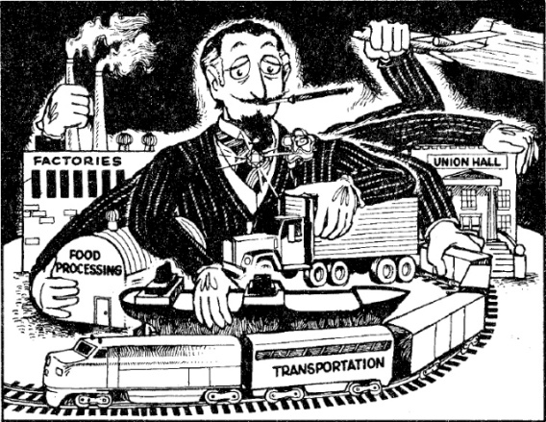
The millions of working families of America are now indebted to the few thousand Banking Families for twice the assessed value of the entire United States. And these Banking Families obtained that debt against us for the cost of paper, ink, and bookkeeping!

The Interest Amount is Never Created
The only way new money (which is not true money, but is “credit” representing a debt), goes into circulation in America is when it is borrowed from Bankers. When the State and people borrow large sums, we seem to prosper. However, the Bankers “create” only the amount of the principal of each loan, never the extra amount needed to pay the interest. Therefore, the new money never equals the new debt added. The amounts needed to pay the interest on loans is not “created,” and therefore does not exist!
Under this kind of a system, where new debt always exceeds the new money no matter how much or how little is borrowed, the total debt increasingly outstrips the amount of money available to pay the debt. The people can never, ever get out of debt!
An example will show the viciousness of this usury-debt system with its “built-in” shortage of money.

If $60,000 is Borrowed,
$255,931.20 Must Be Paid Back
When a citizen goes to a Banker to borrow $60,000 to purchase a home or a farm, the Bank clerk has the borrower agree to pay back the loan plus interest. At 14% interest for 30 years, the Borrower must agree to pay $710.92 per month for a tota1 of $255,931.20. The clerk then requires the citizen to assign to the Banker the right of ownership of the property if the Borrower does not make the required payments. The Bank clerk then gives the Borrower a $60,000 check or a $60,000 deposit slip crediting the Borrower’s checking account with $60,000.
The Borrower then writes checks to the builder, subcontractors, etc., who in turn write checks. $60,000 of new “checkbook” money is thereby added to “money in circulation.”
However, and this is the fatal flaw in a usury system, the only new money created and put into circulation is the amount of the loan, $60,000. The money to pay the interest is NOT created, and therefore was NOT added to “money in circulation.”
Even so, this Borrower (and those who follow him in ownership of the property) must earn and TAKE OUT OF CIRCULATION $255,931, almost $200,000 MORE than he put IN CIRCULATION when he borrowed the origina1 $60,000. (By the way, it is this interest which cheats all families out of nicer homes. It is not that they can’t afford them; it is because the Banker’s usury forces them to pay for 4 homes to get one!)
Every new loan puts the same process in operation. Each borrower adds a small sum to the total money supply when he borrows, but the payments on the loan (because of interest) then deduct a much LARGER sum from the total money supply.
There is therefore no way all debtors can pay off the money-lenders. As they pay the principal and interest, the money in circulation disappears. All they can do is struggle against each other, borrowing more and more from the money-lenders each generation. The money-lenders (Bankers), who produce nothing of value, slowly, then more rapidly, gain a death grip on the land, buildings, and present and future earnings of the whole working population. Proverbs 22:7 has come to pass in America. The borrowers have become the servants of the lenders. No wonder God Almighty forbids interest on loans.

Small Loans Do the Same Thing
If you haven’t quite grasped the impact of the above, let us consider a small auto loan for 3 years at 18% interest. Step 1: Citizen borrows $5,000 and pays it into circulation (it goes to the dealer, factory, miner, etc.) and signs a note agreeing to pay the Banker $6,500. Step 2: Citizen pays $180 per month of his earnings to the Banker. In 3 years he will take OUT of circulation $1,500 more than he put IN circulation.
Every loan of Banker “created” money (credit) causes the same thing to happen. Since this has happened millions of times since 1913 (and continues today), you can see why America has gone from a prosperous, debt-free nation to a debt-ridden nation where practically every home, farm and business is paying usury-tribute to some Banker. The usury-tribute to the Bankers on personal, local, State and Federal debt totals more than the combined earnings of 25% of the working people. Soon it will be 50% and continue up.

This is Why Bankers Prosper in Good Times or Bad
In the millions of transactions made each year like those above, little actual currency changes hands, nor is it necessary that it do so. 95% of all “cash” transactions in the U.S. are by check, so the Banker is perfectly safe in “creating” that so-called “loan” by writing the check or deposit slip, not against actual money, but AGAINST YOUR PROMISE TO PAY IT BACK! The cost to him is paper, ink and a few dollars in salaries and office costs for each transaction. It is “check-kiting” on an enormous scale. The profits increase rapidly, year after year, as shown below.

The Cost To You? Eventually, Everything!
In 1910 the U.S. Federal debt was only $1 billion, or $12.40 per citizen. State and local debts were practically non-existent.
By 1920, after only 6 years of Federal Reserve shenanigans, the Federal debt had jumped to $24 billion, or $228 per person.
In 1960 the Federal debt reached $284 billion, or $1,575 per citizen and State and local debts were mushrooming.
By 1981 the Federal debt passed $1 trillion and was growing exponentially as the Banker’s tripled the interest rates. State and local debts are now MORE than the Federal, and with business and personal debts totalled over $6 trillion, 3 times the value of all land and buildings in America.
lf we signed over to the money-lenders all of America we would still owe them 2 more Americas (plus their usury, of course!)
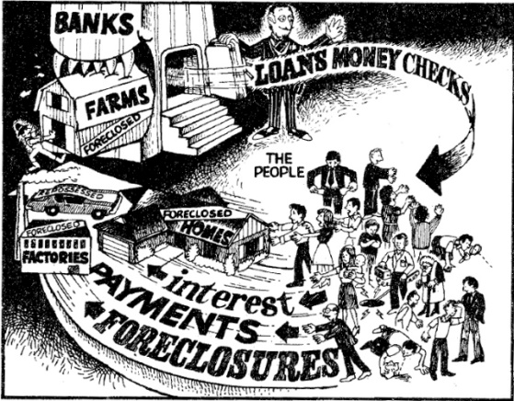
However, they are too cunning to take title to everything. They will instead leave you with some “illusion of ownership” so you and your children will continue to work and pay the Bankers more of your earnings in ever-increasing debts. The “establishment” has captured our people with their ungodly system of usury and debt as certainly as if they had marched in with a uniformed army.

For The Gamblers Among My Readers
To grasp the truth that periodic withdrawal of money through interest payments will inexorably transfer all wealth in the nation to the receiver of interest, imagine yourself in a poker or dice game where everyone must buy the chips (the medium of exchange) from a “banker” who does not risk chips in the game, but watches the table and every hour reaches in and takes 10% to 15% of all the chips on the table. As the game goes on, the amount of chips in the possession of each player will go up and down with his “luck.” However, the TOTAL number of chips available to play the game (carry on trade and business) will decrease rapidly.
The game will get low on chips, and some will run out. If they want to continue to play, they must buy or borrow them from the “banker.” The “banker” will sell (lend) them ONLY if the player signs a “mortgage” agreeing to give the “banker” some real property (car, home, farm, business, etc.) if he cannot make periodic payments to pay back all of the chips plus some EXTRA ones (interest). The payments must be made on time, whether he wins (makes a profit) or not.
It is easy to see that no matter how skillfully they play, eventually the “banker” will end up with all of his original chips back, and except for the very best players, the rest, if they stay in long enough, will lose to the “banker” their homes, their farms, their businesses, perhaps even their cars, watches, rings, and the shirts off their backs!
Our real-life situation is MUCH WORSE than any poker game. In a poker game none is forced to go into debt, and anyone can quit at any time and keep whatever he still has. But in real life, even if we borrow little ourselves from the Bankers, the local, State, and Federal governments borrow billions in our name, squander it, then confiscate our earnings from us and pay it back to the Bankers with interest. We are forced to play the game, and none can leave except by death. We pay as long as we live, and our children pay after we die. If we cannot pay, the same government sends the police to take our property and give it to the Bankers. The Bankers risk nothing in the game; they just collect their percentage and “win it all.” In Las Vegas and at other gambling centers, all games are “rigged” to pay the owner a percentage, and they rake in millions. The Federal Reserve Bankers’ “game” is also rigged, and it pays off in billions!
In recent years Bankers added real “cards” to their game. “Credit” cards are promoted as a convenience and a great boon to trade. Actually, they are ingenious devices by which Bankers collect 2% to 5% of every retail sale from the seller and 18% interest from buyers. A real “stacked” deck!

Yes, It’s Political, Too
Democrat, Republican, and Independent voters who have wondered why politicians always spend more tax money than they take in should now see the reason. When they begin to study our “debt-money” system, they soon realize that these politicians are not the agents of the people but are the agents of the Bankers, for whom they plan ways to place the people further in debt. It takes only a little imagination to see that if Congress had been “creating,” and spending or issuing into circulation the necessary increase in the money supply, THERE WOULD BE NO NATIONAL DEBT, and the over $4 Trillion of other debts would be practically non-existent. Since there would be no ORIGINAL cost of money except printing, and no CONTINUING costs such as interest, Federal taxes would be almost nil. Money, once in circulation, would remain there and go on serving its purpose as a medium of exchange for generation after generation and century after century, just as coins do now, with NO payments to the Bankers whatever!

Mounting Debts and Wars
But instead of peace and debt-free prosperity, we have ever-mounting debt and periodic wars. We as a people are now ruled by a system of Banker-owned Mammon that has usurped the mantle of government, disguised itself as our legitimate government, and set about to pauperize and control our people. It is now a centralized, all-powerful political apparatus whose main purposes are promoting war, spending the peoples’ money, and propagandizing to perpetuate itself in power. Our two large political parties have become its servants. the various departments of government its spending agencies, and the Internal Revenue its collection agency.
Unknown to the people, it operates in close cooperation with similar apparatuses in other nations, which are also disguised as “governments.” Some, we are told, are friends. Some, we are told, are enemies. “Enemies” are built up through international manipulations and used to frighten the American people into going billions of dollars more into debt to the Bankers for “military preparedness,” “foreign aid to stop communism,” “minority rights,” etc. Citizens, deliberately confused by brainwashing propaganda, watch helplessly while our politicians give our food, goods, and money to Banker-controlled alien governments under the guise of “better relations” and “easing tensions.” Our Banker-controlled government takes our finest and bravest sons and sends them into foreign wars with obsolete equipment and inadequate training, where tens of thousands are murdered, and hundreds of thousands are crippled. Other thousands are morally corrupted, addicted to drugs, and infected with venereal and other diseases, which they bring back to the United States. When the “war” is over, we have gained nothing, but we are scores of billions of dollars more in debt to the Bankers, which was the reason for the “war” in the first place!
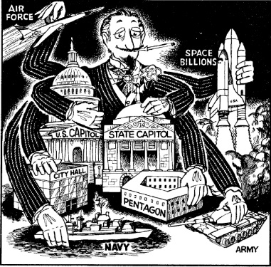

And There’s More
The profits from these massive debts have been used to erect a complete and almost hidden economic and political colossus over our nation. They keep telling us they are trying to do us “good,” when in truth they work to bring harm and injury to our people. These would-be despots know it is easier to control and rob an ill, poorly-educated and confused people than it is a healthy and intelligent population, so they deliberately prevent real cures for diseases, they degrade our educational systems, and they stir up social and racial unrest. For the same reason they favor drug use, alcohol, racial intermarriage, sexual promiscuity, abortion, pornography, and crime. Everything which debilitates the minds and bodies of the people is secretly encouraged, as it makes the people less able to oppose them or even to understand what is being done to them.
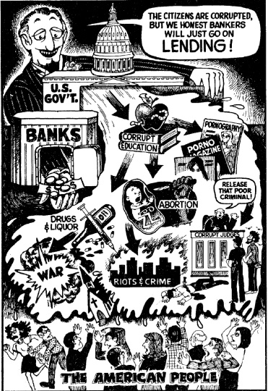
Family, morals, love of Country, the Christian religion, all that is honorable is being swept away, while they try to build their new, subservient man. Our new “rulers” are trying to change our whole racial, social, religious, and political order, but they will not change the debt-money economic system by which they rob and rule. Our people have become tenants and “debt-slaves” to the Bankers and their agents in the land our fathers conquered. It is conquest through the most gigantic fraud and swindle in the history of mankind. And we remind you again: The key to their wealth and power over us is their ability to create “money” out of nothing and lend it to us at interest. If they had not been allowed to do that, they would never have gained secret control of our nation. How true Solomon’s words are: “The rich ruleth over the poor, and the borrower is servant to the lender” (Proverbs 22:7).
God Almighty warned in the Bible that one of the curses which would come upon His People for disobeying His Laws was:
“The stranger that is within thee shall get up above thee very high; and thou shalt come down very low. He shall lend to thee, and thou shalt not lend to him; he shall be the head, and thou shalt be the tail” [Deut. 28: 44-45].
Most of the owners of the largest banks in America are of Eastern European ancestry and connected with the Rothschild European banks. Has that warning come to fruition in America?
Let us now consider the correct method of providing the medium of exchange (money) needed by our people.
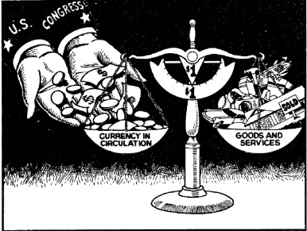

The Constitutional Way —
Every Citizen A Stockholder
If we would have used the Constitutional way of “creating” the money needed in the nation, the Federal Congress would spend most of its time and study on the issuance and control of an adequate supply of stable money for the people. If an increase of population and production required an increase in the medium of exchange, Congress would authorize the “coining,” (i.e., printing) of the determined amount. Some could be used to pay current legitimate expenses of the Federal Government, with the balance paid directly to the citizens. Records for payment would be similar to Social Security records, except a citizen would be recorded at birth, instead of when he first goes to work. Each person on the records as of the date of the Congressional authorization would receive an equal amount just as if he were a stockholder holding one share. Just think — a payment of only $20 to each citizen would put $4 billion of debt-free and interest-free money into circulation.
Such a suggestion always scares the Bankers. Their propagandists will immediately cry, “printing press money,” and warn that it would soon be “worthless” and would “cause inflation.”
The truth is their immense usury charges on their “created” credit (our debt) is the sole cause of “inflation.” All prices on all industry, trade and labor must be raised periodically to pay the ever increasing usury charges. That is the ONLY cause of higher prices, and the money-changers spend millions in propaganda to keep you from realizing that.
The money-creators (Bankers) know that if we ever tried a Constitutional issue of debt-free, interest-free currency, even a limited issue, the benefits would be apparent immediately. That they must prevent. Abraham Lincoln was the last President to issue such debt-free and interest-free currency (in 1863) and he was assassinated shortly thereafter.
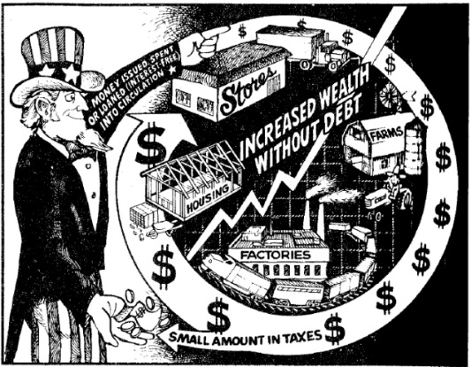

No Banker’s Plunder
Under a Constitutional system no private banks would exist to rob the people. Government banks under the control of the people’s representatives would issue and control all money and credit. They would issue not only actual currency, but could lend limited credit at no interest for the purchase of capital goods, such as homes. A $60,000 loan would require only $60.000 repayment, not $255,931 as it is now. Everyone who supplied materials and labor for the home would get paid just as they do today, but the Bankers would NOT get $195,931 in usury, AND THAT IS WHY THEY RIDICULE AND DESTROY ANYONE SUGGESTING GOVERNMENT (CITIZENS’) MONEY WITHOUT INTEREST AND WITHOUT DEBT.
History tells us of debt-free and interest-free money issued by governments. The American colonies did it in the 1700’s and their wealth soon rivaled England and brought restrictions from Parliament, which led to the Revolutionary War. Abraham Lincoln did it in 1863 to help finance the Civil War. He was later assassinated by an agent of the Rothschild Bank. No debt-free or interest-free money has been issued in America since then. Several Arab nations issue interest-free loans to their citizens today. The Saracean Empire forbad interest on money for 1,000 years, and its wealth outshone even Saxon Europe. Mandarin China issued its own money, interest-free and debt-free, and historians and collectors of art today consider those centuries to be China’s time of greatest wealth, culture and peace.
Germany issued debt-free and interest-free money from 1935 and on, accounting for its startling rise from the depression to a world power in 5 years. Germany financed its entire, government and war operation from 1935 to 1945 without gold and without debt, and it took the whole Capitalist and Communist world tn destroy the German power over Europe and bring Europe back under the heel of the Bankers. Such history of money does not even appear in the textbooks of public (government) schools today.
Issuing money which doesn’t have to be paid back in interest leaves the money available to use in the exchange of goods and services and its only continuing cost is replacement as the paper wears out. Money is the paper ticket by which such transfers are made and should always be in sufficient quantity to transfer all possible production of the nation to ultimate consumers.
It is as ridiculous for a nation to say to its citizens, “You must consume less because we are short of money,” as it would be for an Airline to say “Our planes are flying, but we can’t take you because we are short of tickets.”

Why You Haven’t Known
We realize this small, and necessarily incomplete, article on money may be charged with oversimplification. Some may say that if it is that simple the people would have known about it, and it could not have happened. But this MONEY-LENDERS’ consPIRACY is as old as Babylon, and even in America it dates far back before the year 1913. Actually, 1913 may be considered the year a which their previous plans came to fruition, and the way opened for complete economic conquest of our people. The consPIRACY is old enough in America so that its agents have been, for many years, in positions such as newspaper publishers, editors, columnists, church ministers, university presidents, professors, textbook writers, labor union leaders, movie makers, radio and TV commentators, politicians from school board members to U.S. presidents, and many others.
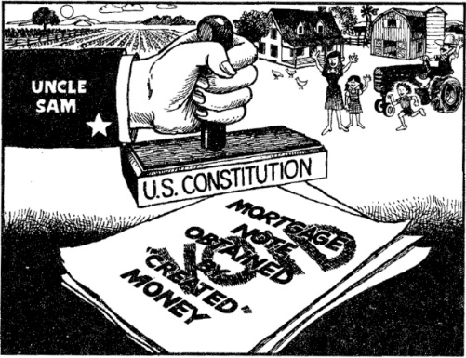

Controlled News and Information
These agents control the information available to our people. They manipulate public opinion, elect whom they will locally and nationally, and never expose the crooked money system. They promote school bonds, municipal bonds, expensive and detrimental farm programs, “urban renewal,” foreign aid, and many other schemes which will put the people more into debt to the Bankers. Thoughtful citizens wonder why billions are spent on one program and billions on another which may duplicate it or even nullify it, such as paying some farmers not to raise crops, while at the same time building dams or canals to irrigate more farm land. Crazy or stupid? Neither. The goal is more debt. Thousands of government-sponsored ways to waste money go on continually. Most make no sense, but they are never exposed for what they really are, builders of “billions for the bankers and debts for the people.”
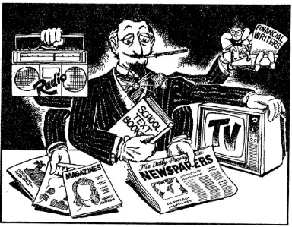
So-called “economic experts” write syndicated columns in hundreds of newspapers, craftily designed to prevent the people from learning the simple truth about our money system. Commentators on radio and TV, preachers, educators, and politicians blame the people as wasteful, lazy, or spend-thrift, and blame the workers and consumers for the increase in debts and the inflation of prices, when they know the cause is the debt-money system itself. Our people are literally drowned in charges and counter-charges designed to confuse them and keep them from understanding the unconstitutional and evil money-system that is so efficiently and silently robbing the farmers, the workers, and the businessmen of the fruits of their labors and of their freedoms.
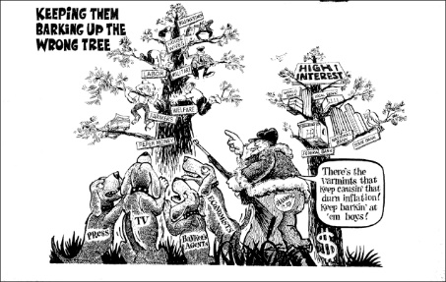
When some few Patriotic people or organizations who know the truth begin to expose them or try to stop any of their mad schemes, they are ridiculed and smeared as “right-wing extremists,” “super-patriots,” “ultra-rightists,” “bigots,” “racists,” even “fascists” and “anti-semites.” Any name is used which will cause them to shut up or will at least stop other people from listening to the warning they are giving. Articles and books such as you are now reading are kept out of schools, libraries, and book stores.
Some, who are especially vocal in their exposure of the treason against our people, are harassed by government agencies such as the EPA, OSHA, the IRS, and others, causing them financial loss or bankruptcy. Using the above methods, they have been completely successful in preventing most Americans from learning the things you have read in this pamphlet. However, in spite of their control of information, they realize many citizens are learning the truth. Therefore, to prevent violence or armed resistance to their plunder of America, they plan to register all firearms and eventually to disarm all citizens. They have to eliminate most guns, except those in the hands of their government police and army.

Tell The People
The “almost hidden” conspirators in politics, religion, education, entertainment, and the news media are working for a Banker-owned United States in a Banker-owned world under a Banker-owned World Government!
Love of Country, compassion for your Race, and concern for your children should make you deeply interested in this, America’s greatest problem, for our generation has not suffered under the “yoke” as the coming generations will. Usury and taxes will continue to take a larger and larger part of the annual earnings of the people and put them into the pockets of the Bankers and their political Agents. Increasing “government” regulations will prevent citizen protest and opposition to their control. Is it possible that your grandchildren will own neither home nor car, but will live in “government-owned” apartments and ride to work in “government-owned” buses (both paying usury to the Bankers), AND BE ALLOWED TO KEEP JUST ENOUGH OF THEIR EARNINGS TO BUY A MINIMUM OF FOOD AND CLOTHING while their Rulers wallow in luxury? In Asia and eastern Europe it is called “communism;” in America it is called “Democracy” and “Capitalism.”
America will not shake off her Banker-controlled dictatorship as long as the people are ignorant of the hidden controllers. International financiers, who control most of the governments of the nations, and most sources of information, seem to have us completely within their grasp. They are afraid of only one thing: an awakened Patriotic Citizenry, armed with the truth, and with a trust in Almighty God for deliverance. This pamphlet has given you the truth about their iniquitous system. What you do with it is in your hands, as in the hands of Divine Providence. “The fear of man bringeth a snare; but whoso putteth his trust in the Lord shall be safe (Proverbs 29: 25).
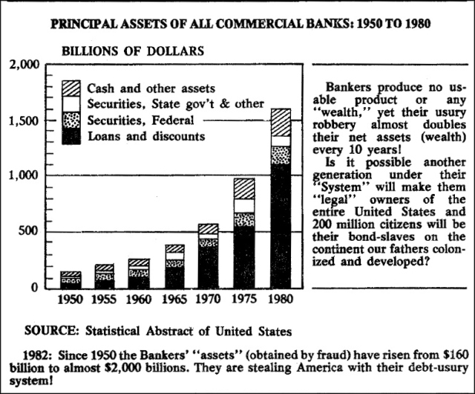

Audit The Federal Reserve System?
The Federal Reserve has never been audited by the government since it took over our money and credit in 1913. In 1975 a bill, H.R. 4316, to require an audit was introduced in Congress.
During the April, 1975 hearings, this author submitted a statement favoring the audit, as did many others. Due to pressure from the money controllers, it was not passed. No audit of the Fed has ever been made.

Why Haven’t They Told You?
Why haven’t they told you about this scandal — the greatest fraud in history which has caused Americans and others to spill oceans of blood, pay trillions of dollars interest on fraudulent loans and burden themselves with unnecessary taxes?
Who are “they”? “They” are all of the politicians of the two old parties and elected officials. All “educational” groups like the League of Women Voters, the Heritage Foundation and the American Civil Liberties Union (ACLU). All news services, such as the Associated Press and the United Press International. All daily newspapers, including the New York “Times” and Los Angeles “Times.” All weekly “news” magazines, such as “Time” and “Newsweek.” All economics and history professors at all colleges and universities. All financial newsletter publishers. All labor leaders. All televangelists, your local minister, priest or rabbi. All of the above and more are hiding the truth from you.
When the credit/debt bubble is pricked by the bankers they will foreclose on America. Then, they will own it all. There may be a “managed chaos” — riots and terrorism — to alarm the people with the fear of anarchy as the bankers prepare to impose a communistic dictatorship on America as the “solution” for the problems they, themselves, have created.
Only an educated people will be able to resist the lies of the bankers’ stooges. This is why it is important for you to know the truth about how the bankers make billions for themselves and bring debts to the people.
WHAT SOME FAMOUS MEN HAVE SAID ABOUT THE MONEY QUESTION
ALAN GREENSPAN: “In the absence of the gold standard, there is no way to protect savings from confiscation through inflation. … This is the shabby secret of the welfare statists’ tirades against gold. Deficit spending is simply a scheme for the confiscation of wealth. Gold stands in the way of this insidious process. It stands as a protector of property rights. If one grasps this, one has no difficulty in understanding the statists’ antagonism toward the gold standard.”
PRESIDENT THOMAS JEFFERSON: “The system of banking [is] a blot left in all our Constitutions, which, if not covered, will end in their destruction… I sincerely believe that banking institutions are more dangerous than standing armies; and that the principle of spending money to be paid by posterity… is but swindling futurity on a large scale.”
PRESIDENT JAMES A. GARFIELD: “Whoever controls the volume of money in any country is absolute master of all industry and commerce”.
CONGRESSMAN LOUIS McFADDEN: “The Federal Reserve(Banks) are one of the most corrupt institutions the world has ever seen. There is not a man within the sound of my voice who does not know that this Nation is run by the International Bankers”.
HORACE GREELEY: “While boasting of our noble deeds were careful to conceal the ugly fact that by an iniquitous money system we have nationalized a system of oppression which, though more refined, is not less cruel than the old system of chattel slavery.
THOMAS A. EDISON: “People who will not turn a shovel full of dirt on the project (Muscle Shoals Dam) nor contribute a pound of material, will collect more money from the United States than will the People who supply all the material and do all the work. This is the terrible thing about interest …But here is the point: If the Nation can issue a dollar bond it can issue a dollar bill. The element that makes the bond good makes the bill good also. The difference between the bond and the bill is that the bond lets the money broker collect twice the amount of the bond and an additional 20%. Whereas the currency, the honest sort provided by the Constitution pays nobody but those who contribute in some useful way. It is absurd to say our Country can issue bonds and cannot issue currency. Both are promises to pay, but one fattens the usurer and the other helps the People.”
PRESIDENT WOODROW WILSON: “A great industrial Nation is controlled by its system of credit. Our system of credit is concentrated. The growth of the Nation and all our activities are in the hands of a few men. We have come to be one of the worst ruled, one of the most completely controlled and dominated Governments in the world – no longer a Government of free opinion no longer a Government by conviction and vote of the majority, but a Government by the opinion and duress of small groups of dominant men”. (Just before he died, Wilson is reported to have stated to friends that he had been “deceived” and that “I have betrayed my Country”. He referred to the Federal Reserve Act passed during his Presidency.)
SIR JOSIAH STAMP,(President of the Bank of England in the 1920’s, the second richest man in Britain): “Banking was conceived in iniquity and was born in sin. The Bankers own the earth. Take it away from them, but leave them the power to create deposits, and with the flick of the pen they will create enough deposits to buy it back again. However, take it away from them, and all the great fortunes like mine will disappear and they ought to disappear, for this would be a happier and better world to live in. But, if you wish to remain the slaves of Bankers and pay the cost of your own slavery, let them continue to create deposits”.
MAJOR L .L. B. ANGUS: “The modern Banking system manufactures money out of nothing. The process is perhaps the most astounding piece of sleight of hand that was ever invented. Banks can in fact inflate, mint and unmint the modern ledger-entry currency”.
RALPH M. HAWTREY (Former Secretary of the British Treasury): “Banks lend by creating credit. They create the means of payment out of nothing”.
ROBERT HEMPHILL (Credit Manager of Federal Reserve Bank, Atlanta, Ga.): “This is a staggering thought. We are completely dependent on the commercial Banks. Someone has to borrow every dollar we have in circulation, cash or credit. If the Banks create ample synthetic money we are prosperous; if not, we starve. We are absolutely without a permanent money system. When one gets a complete grasp of the picture, the tragic absurdity of our hopeless position is almost incredible, but there it is. It is the most important subject intelligent persons can investigate and reflect upon. It is so important that our present civilization may collapse unless it becomes widely understood and the defects remedied very soon”.
http://www.maxexchange.com/ybj/billions_for_the__bankers.htm
http://www.scribd.com/doc/15251937/Sheldon-Emry-Billions-For-The-Bankers-And-Debts-For-The-People

