
by Eustace Mullins
from FourWinds10 Website

Dedicated to two of the finest scholars of the twentieth century
GEORGE STIMPSON and EZRA POUND
who generously gave of their vast knowledge to a young writer to guide him in a field which he could not have managed alone.

ACKNOWLEDGEMENTS
I wish to thank my former fellow members of the staff of the Library of Congress whose very kind assistance, cooperation and suggestions made the early versions of this book possible.

I also wish to thank the staffs of the Newberry Library, Chicago, the New York City Public Library, the Alderman Library of the University of Virginia, and the McCormick Library of Washington and Lee University, Lexington, Virginia, for their invaluable assistance in the completion of thirty years of further research for this definitive work on the Federal Reserve System.

ABOUT THE COVER
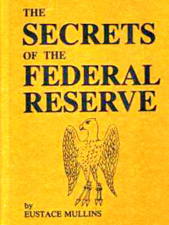 | The cover reproduces the outline of the eagle from the red shield, the coat of arms of the city of Frankfurt, Germany, adapted by Mayer Amschel Bauer (1744-1812) who changed his name from Bauer to Rothschild ("Red Shield").  Rothschild added five golden arrows (right image) held in the eagle’s talons, signifying his five sons who operated the five banking houses of the international House of Rothschild:  - Frankfurt  - London  - Paris  - Vienna  - Naples | 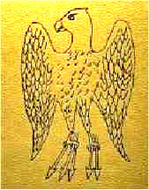

Table of Contents
- Forward
- Introduction - Jefferson's Opinion on the Constitutionality of the Bank
- Chapter - Jekyll Island
- Chapter - The Aldrich Plan
- Chapter - The Federal Reserve Act
- Chapter - The Federal Advisory Council
- Chapter - The House of Rothschild
- Chapter - The London Connection
- Chapter - The Hitler Connection
- Chapter - World War One
- Chapter - The Agricultural Depression
- Chapter - The Money Creators
- Chapter - Lord Montagu Norman
- Chapter - The Great Depression
- Chapter - The 1930's
- Chapter - Congressional Expose
- Addendum
- Appendix I
- Biographies
- Bibliography
- Index
- Frequently Asked Questions about the Federal Reserve System
Return to Temas / Libros

Return to The Rothschilds

Return to The Federal Reserve

Return to Temas / Sociopolitica

